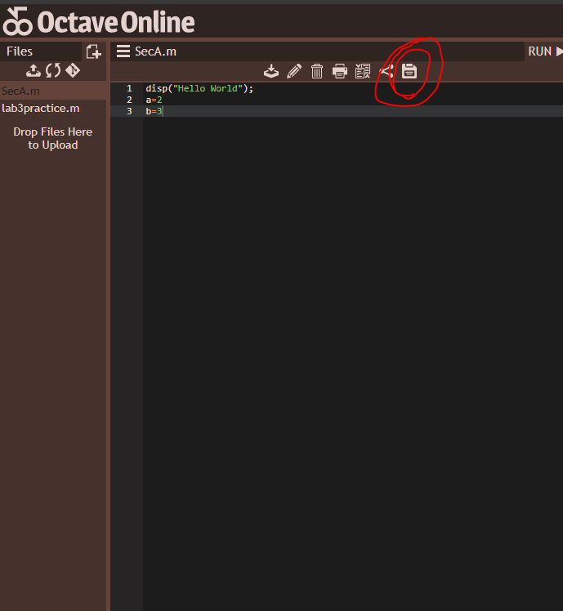

TO RUN YOU CODE YOU ALWAYS HAVE TO SAVE YOUR CODE.

Otherwise output of newly written code won’t be seen.

|  |  |
| --- | --- |
| Code | Output |
| disp("Hello World"); // display function, like printf | Hello World |
| More “beautiful” output:  disp([‘Factorial value is ’, num2str(factValue)]) |  |
| More advanced output using fprintf:  fprintf('Factorial Value is: %4i\n',factValue) |  |
| Function writing : also can take input like this ,  function output =SecA(a,b) #a,b is for input variable  # here ‘SacA’ is the file name  sum=a+b;  output =sum; #to output we keep value at out put  we can run this now by clicking:    Then the program will ask for input:  like this | ans = 3 |
| Or we can go to terminal and write  SecA(3,4) # a=3,b=4 | ans = 7 |
| function output=SecA(a,b)  sum=a+b;  fprintf('Factorial Value is: %i\n',sum)  fprintf('Factorial Value is: %4i\n',sum)  fprintf('Factorial Value is: %4f\n',sum)  disp([‘Factorial value is ’, num2str(sum)]) #’num2str’ converts #integer to string | Factorial Value is: 3  Factorial Value is: 3  Factorial Value is: 3.000000  value is 3 |